**Yr. 12 ATAR Human Biology ATHBY**

**Task 10: Science Inquiry**

**Conditions**

Time for task:

**Part A:** You have one week to research the topic and complete notes. You **may not** use these notes for Part B.

**Part B:** 30 minutes for in class validation – examination-style extended answer question.

**Task weighting: 3 %**

**Introduction** Since identification of the CFTR gene over 25 years ago, gene therapy for cystic fibrosis (CF) has been actively developed. Gene therapy is currently the most advanced form of CF genetic medicine. Since cloning of the CFTR gene in 1989 extensive pre-clinical research led to approximately 27 clinical trials involving about 600 patients being completed.

Recently, a double-blind, placebo-controlled multi-dose trial was carried out to test the effectiveness of liposome vectors in carrying the normal CFTR gene into cystic fibrous suffers.

Patients 12 years or older with moderate or mild lung disease as a result of cystic fibrous received 5 ml of nebulized pGM (normal CFTR gene in a liposome vector) or 5 ml 0.9% saline every month for 12 months. The scientists measured the change in lung function of patients as a relative change of percent predicted forced expiratory volume in 1 second (FEV1). Lung function (FEV1) was measured at each visit before administration of the treatment.

Data from 116 patients (who received nine or more doses) were analysed and the results are presented on the graphs below. Data are expressed as relative percent change from the baseline FEV1. Error bars show the standard error of the mean. .

(A) All patients receiving treatment

(B) Patients with more severe reduced lung function at start of treatment

(Baseline FEV1 50–70%),

(C) Patients with less severe reduced lung function at start of treatment

(Baseline FEV1 70–90%).

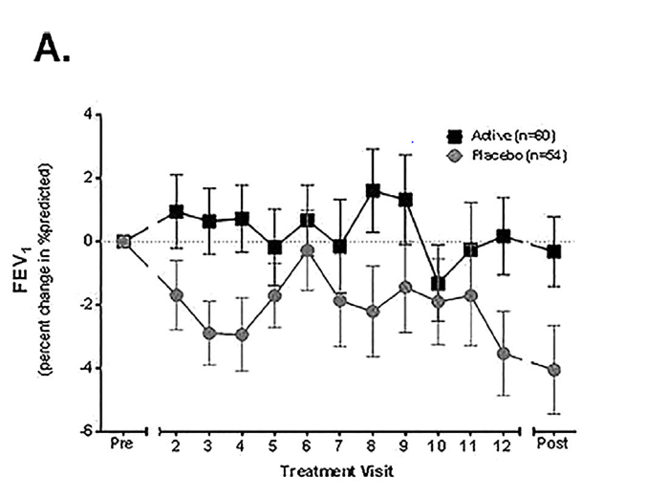

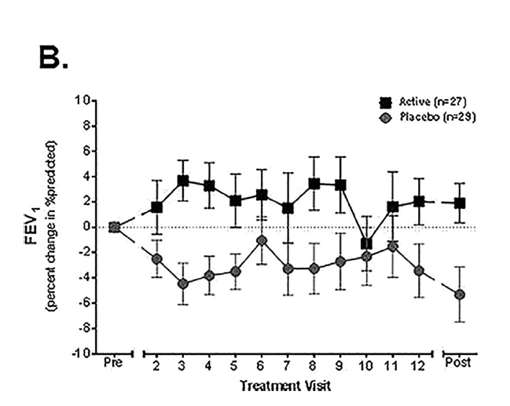

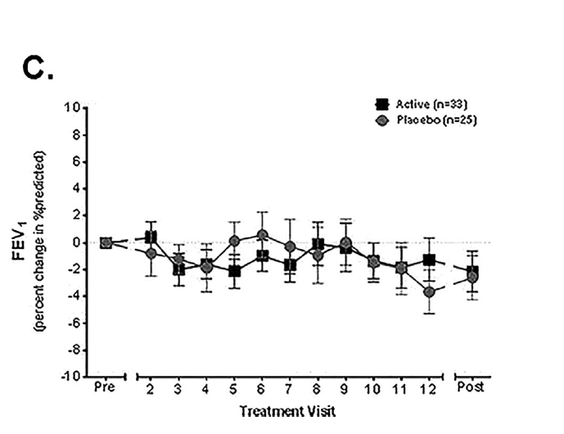

Questions

1. Propose a hypothesis for this experiment
2. Define ‘placebo’.
3. What was the placebo treatment administered during this research
4. Explain the term ‘double-blind’ and why researchers would use this approach.
5. With reference to the data provided, state two conclusions that can be drawn from the experiment.
6. Error bars are graphical representations of the variability of data and are used on graphs to indicate the [error](https://en.wikipedia.org/wiki/Errors_and_residuals_in_statistics) or uncertainty in a reported measurement.  What is the benefit of using error bars?
7. Explain why scientists would include a post-treatment measurement

8 After considering the data and your conclusions, what treatment advice would you provide to a patient with less severe lung function (Baseline FEV1 70–90%). Explain your response, referring to data.